Exercises:

1. Remember a Georgian or foreign film / films in which trying to escape from something is the main story line.
2. Create a poster with the title "Love is vertical and rotating at the same time".
3. How would you entitle this photo?
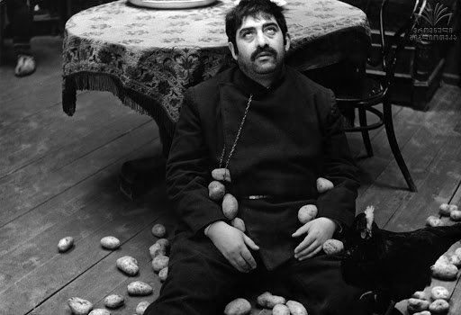

4."Kuleshov Effect" is the combination of two different, unconnected, independent frames in a way, that it acquires a new meaning. Describe and entitle a pair of shots according to this example:

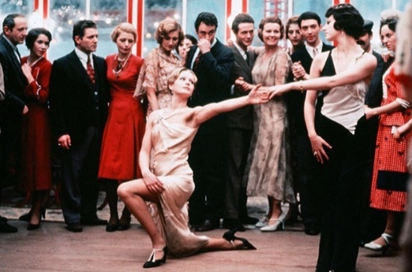
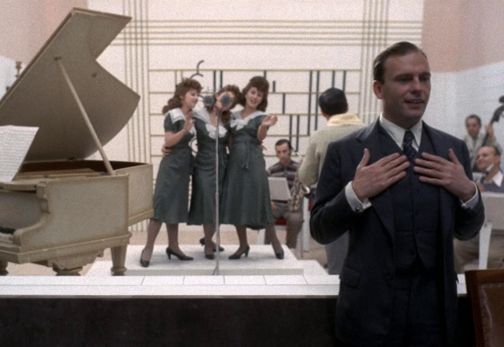

+ =

Footage from Bernardo Bertoluccis’ film "The Conformist"

5. What do you think about the Soviet Dissident Movement (It conflicted to established beliefs, policies or systems), why did this event occur and did it achieve its goals? Write an essay (150-200 words).

